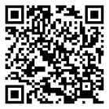
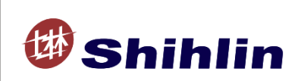
Shihlin Electric SDE Series AC Drive
Installation Guide

SDE-010A2(U)/ SDE-020A2(U)/ SDE-040A2(U)
SDE-075A2(U)/ SDE-100A2(U)/ SDE-150A2(U)
SDE-200A2(U)/SDE-300A2(U)
Thank you for choosing Shihlin SDE Series AC Drive.
The instruction will describe on the use and points for attention of products. Before installing, please be sure to carefully read the Installation Instructions, so that the AC servo drive can be used in proper and safe way.
1. Safety Instructions
Safety Instructions
- Installation, operation, maintenance and inspection must be performed by qualified personnel.
- In this instruction, the safety instruction levels are classified into "Warning" and "Caution".
Warning: Incorrect handling may cause hazardous conditions, resulting in death or severe injury.
Caution: Incorrect handling may cause hazardous conditions, resulting in medium or slight injury, or may cause only material damage.

Warning
- While the AC servo drive power is ON, do not open the front cover or the wiring cover. Do not run the AC servo drive with the front cover or the wiring cover removed .Otherwise you may access the exposed high voltage terminals or the charging part of the circuitry and get an electric shock.
- It is crucial to turn off the motor drive power before any wiring installation or inspection is made. Before the AC servo drive CHARGE light is OFF, which indicates that there is still high voltage in it, please do not touch the internal circuit and components. Operation must be made after measuring the voltage which is less than 24 VDC between ＋/P and－/N and with avometer.
- The AC servo drive must be connected to the ground properly.
- Do not operate or touch the radiator or handle the cables with wet hands. Otherwise you may get an electric shock.
- Do not change the cooling fan while power is ON. It is dangerous to change the cooling fan while power is ON.

Caution
- The voltage applied to each terminal must be the ones specified in the Instruction Manual. Otherwise burst, damage, etc. may occur.
- Do not conduct a pressure test on the components inside the AC servo drive, for semiconductor of the AC servo drive is easily to be broke down and damaged by high voltage.
- While power is ON or for some time after power is OFF, do not touch the AC servo drive as it will be extremely hot. Touching these devices may cause a burn.
- The cables must be connected to the correct terminals. Otherwise burst, damage, etc. may occur.
- The polarity (+ and -) must be correct. Otherwise burst, damage, etc. may occur.
- AC servo drive must be installed on a nonflammable wall without holes (so that nobody touches the AC servo drive heat sink on the rear side, etc.). Mounting it to or near flammable material may cause a fire.
- If the AC servo drive has become faulty, the AC servo drive power must be switched OFF. A continuous flow of large current may cause a fire.
- Do not connect a resistor directly to the DC terminals ＋/P and－/N. Doing so could cause a fire.
2. Product Model

Drive model designation
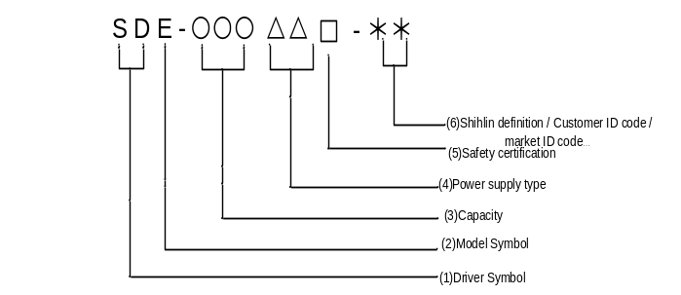
- Driver Symbol：SD on behalf of the servo drive.
- Model Symbol：E.
- Capacity：The output power of the motor. After the motor power output by 1/10 with three code Numbers. Example: 020 represents 200 w，150 represents 1500 w.
- Power supply type：The input power supply specifications.
A2: single phase or three phase, from 200 to 240Va.
- Safety certification: when complying with CE but do not conform to UL，the code is empty;
When complying with both CE and UL, the code is "U".
- Shihlin definition / Customer ID code / market ID code…：example：
Market ID code：TW: Made in Taiwan；CN：Made in China…
Customer ID code：A1…ZZ（By the English words A to Z and the combination of Numbers 0 to 9）
Other definitions…

Motor model designation
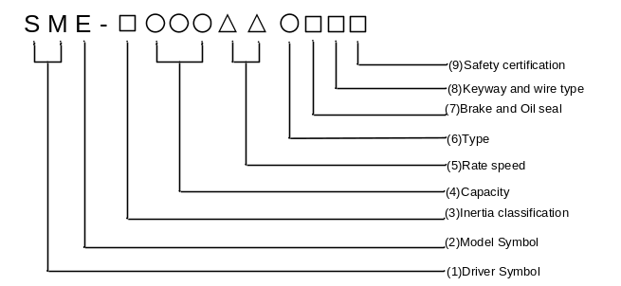

- Driver Symbol：SM on behalf of the servo drive
- Model Symbol：E
- Inertia classification: in accordance with the motor inertia code is as follows:
Symbol | Category
L | low
M | medium
- Capacity：Rated output:
Symbol | 010 | 020 | 040 | 075 | 100 | 150 | 200 | 300
motor power (W) | 100 | 200 | 400 | 750 | 1000 | 1500 | 2000 | 3000
- Rate speed：Rated output rotational speed of the motor:
Symbol | 20 | 30
Rate speed (rpm) | 2000 | 3000
- Type：Shihlin encoder type:
Symbol | S | M
Single turn | 22 | 22
More turn | － | 16
- Brake and Oil seal：Motor is attached to the brake and the oil seal, in the following code:
Symbol | A | B | C | D
brake | － | ● | － | ●
Oil seal | － | － | ● | ●
- Keyway and wire type: motor keyway and line type selection, in the following code:
Symbol | A | B | C | D
Keyway | － | ● | － | ●
Back side cable  cable | － | － | ● | ●
- Safety certification：Motor through safety certification, in the following code:
Symbol | CE certification | conform UL/CE certification
Symbol | - | U

3. Installation Environment
Ambient temperature | -10 ~ +55℃ (non-freezing),※If more than 45 ℃ environment temperature, the forced air circulation around.
Ambient humidity | Below 90%Rh (non-condensing)。
Storage temperature | -20 ~ +65℃。
Surrounding environment | Indoor, no corrosive gas, no flammable gas, no flammable powder.
Altitude | Altitude below 1000 meters
Vibration | 5.9m/ s² (0.6G)below
Grade of protection | IP20
The degree of pollution | 2
4. Installation and Wiring
Please ensure vertical arrangement to keep the cooling effect:

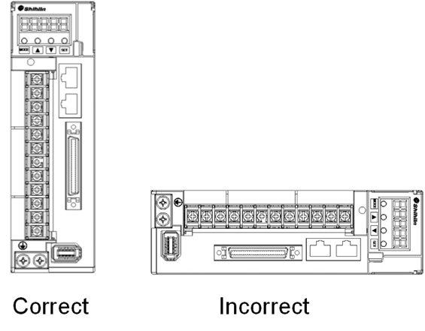

Please comply with installation conditions shown below to ensure enough ventilation space and wiring space for AC servo drive cooling
·Arrangement of single AC servo drive:

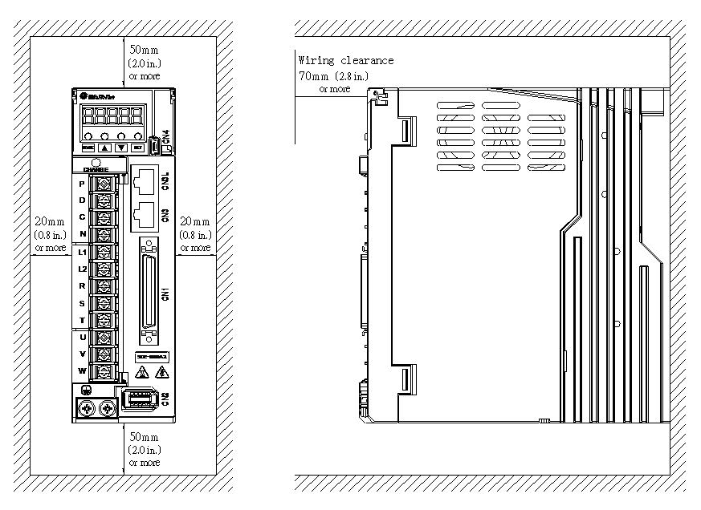

·Arrangement of multiple AC servo drive:
：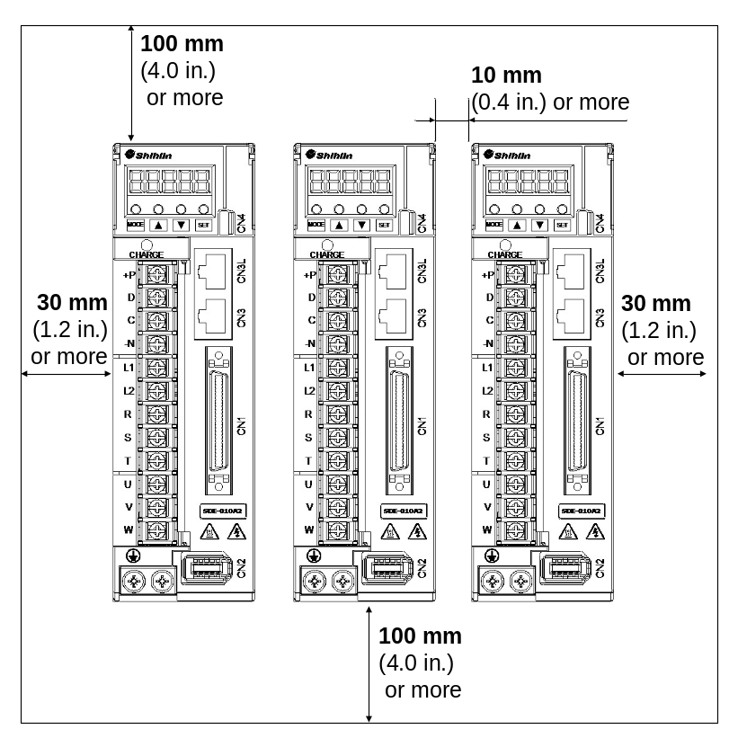

5. Terminal Connection Diagrams

Shihlin servo drive Power supply wiring for the three-phase Power supply, Power ON for a contact, the image of the Power OFF with Alarm Processing for point b.MC/a for the power supply, 1 MC for electromagnetic contactor.

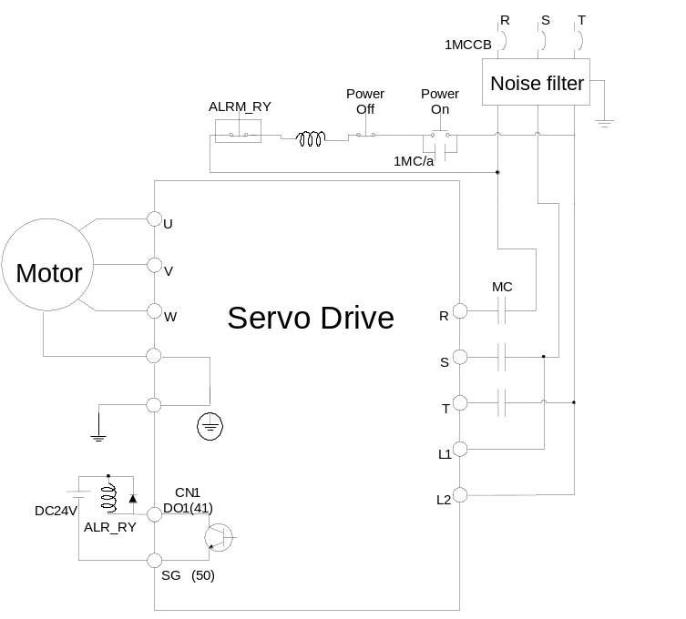

6. Description of drive terminals and sockets
Name | Sign | Description
Main power input terminal | R、S、T | Connect to 3-phase AC power source
Control power input terminal | L1、L2 | Connect to single phase AC power source
Power output terminal | U、V、W、PE
  Terminal code | Wire color
  U | Red
  V | White
  W | Black
  PE | green
Brake resistor terminal | P、D、C
  External resistor | P/C connected to resistor and P/D open.
  Built-in resistor | P/D connect together and make P/C open.
Ground terminal |  | To connect the power ground with the motor ground.
P: ＋ terminal  N: － terminal | P、N | When an active brake device is used for 1.5KW or above, please connect the ＋ terminal of it to the drive’s P terminal, the － terminal to the drive’s N terminal. The active brake device is usually applied when the huge regenerative power produced by the servo motor in heavy duty.
DI/DO connector | CN1 | Connect to the host controller.
Encoder socket | CN2 | Connect to the encoder cable of servo motor.
RS-485 port | CN3/CN3L | Connect CN3 to the superior device and CN3L to the inferior device.
USB port | CN4 | Connect to the USB port of PC.
Absolute encoder battery end connection | CN5 | To connect to absolute encoder battery (buy)

Note 1:① Keep the power lines R/S/T and U/V/W away from other signal lines at least 30cm.
Note 2:② Do not touch the power lines until the charge indicator goes out. When “power off”, there is a large amount of electric charge in the aluminum capacitors inside the servo drive.
Note 3 :①If a longer encoder cable is required, uses the twisted pairs cable and not to exceed 20m. Be sure to upgrade the diameter of wires to avoid signals attenuated when the wire’s length greater than 20m.

7. Motor U, V, W lead wire connector specifications
Shihlin low inertia of the motor end of U, V, W wiring connector specifications (Female connector )：
Drive capacity | Motor model | 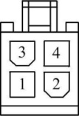  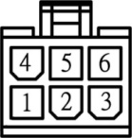  Have brake No brake
100W | SME－L01030○□□□
200W | SME－L02030○□□□
400W | SME－L04030○□□□
750W | SME－L07530○□□□

The following table shows low inertia motors UVW signal of lead wire connector：
PIN | Signal | Wire color
1 | U | Red
2 | V | White
3 | W | Black
4 | PE | Green/yellow (green at the bottom)
5 | NC | Black ( electromagnetic brake)
6 | NC | Black (electromagnetic brake)
Note: the above wiring of the motor itself, even out of joint.

Shihlin low inertia of the motor end of U, V, W wiring connector specifications (Male connector)
Drive capacity | Motor model | 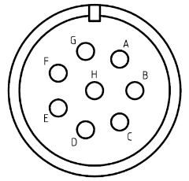
1KW | SME－L10020○□□□
1.5KW | SME－L15020○□□□
2KW | SME－L20020○□□□
3KW | SME－L30020○□□□

Shihlin centre inertia of the motor end of U, V, W wiring connector specifications (Male connector)
Drive capacity | Motor model
1KW | SME－M10020○□□□
1.5KW | SME－M15020○□□□
2KW | SME－M20020○□□□ | 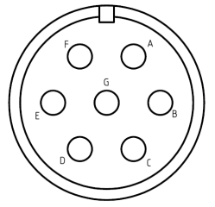
3KW | SME－M30020○□□□
In the table below notes inertia under 3kw motor UVW signal of lead wire connectors
PIN | Signal
A | NC
B | U
C | V
D | W
E | PE
F | NC(electromagnetic brake)
G | NC(electromagnetic brake)
H | NC
⬇Note: the above wiring of the motor itself, even out of joint.

Wire selection
model | power wire [mm²(AWG)]
model | R、S、T | L1、L2 | U、V、W、PE | P、D、C、N | B1、B2
SDE－010A2□ | 2(AWG14) | 2(AWG14) | 2(AWG14) | 2(AWG14) | 2(AWG14)
SDE－020A2□
SDE－040A2□
SDE－075A2□
SDE－100A2□ | 2(AWG14) | 2(AWG14) | 2(AWG14) | 2(AWG14) | 2(AWG14)
SDE－150A2□ | 3.5(AWG12) | 2(AWG14) | 3.5(AWG12) | 2(AWG14) | 2(AWG14)
SDE－200A2□
SDE－300A2□ | 5.5(AWG10) | 2(AWG14) | 5.5(AWG10) | 2(AWG14) | 2(AWG14)
8. CN1 I/O Socket
CN1 connector (cabled side)
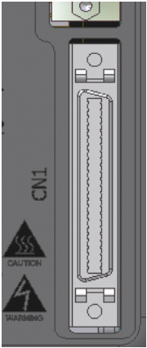
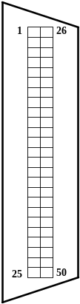
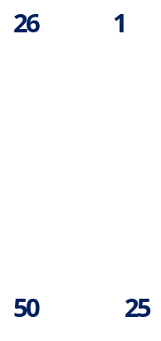

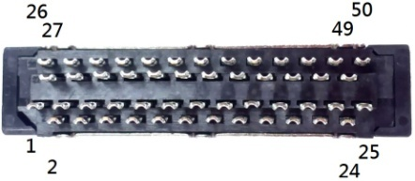

CN1 compatible connector pin order
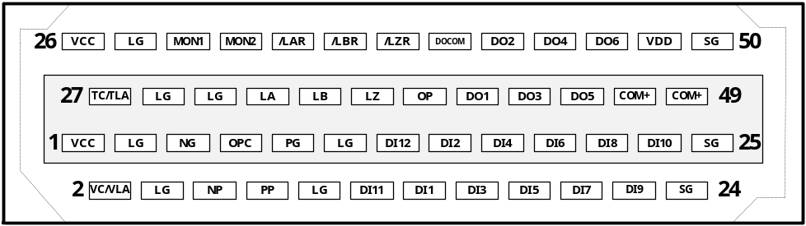
Pin | Sign | Function description | Pin | Sign | Function description
1 | Vcc(15V) | +15V power output | 2 | VC/VLA | Speed analog command/ limit
3 | LG | Analog I/O ground | 4 | LG | Analog I/O ground
5 | NG | Forward/reverse rotation pulse | 6 | NP | Forward/reverse rotation pulse
7 | OPC | Open collector power | 8 | PP | Forward/reverse rotation pulse
9 | PG | Forward/reverse rotation pulse | 10 | LG | Analog I/O ground
11 | LG | Analog I/O ground | 12 | DI11 | Digital input 11
13 | DI12 | Digital input 12 | 14 | DI1 | Digital input 1
15 | DI2 | Digital input 2 | 16 | DI3 | Digital input 3
17 | DI4 | Digital input 4 | 18 | DI5 | Digital input 5
19 | DI6 | Digital input 6 | 20 | DI7 | Digital input 7
21 | DI8 | Digital input 8 | 22 | DI9 | Digital input 9
23 | DI10 | Digital input 10 | 24 | SG | Digital I/O signal ground
25 | SG | Digital I/O signal ground

Pin | code | function | Pin | code | function
26 | Vcc(15V) | +15V power output | 27 | TC/TLA | Torque analog command/limit
28 | LG | Analog I/O ground | 29 | LG | Analog I/O ground
30 | MON1 | Analog output monitor 1 | 31 | LG | Analog I/O ground
32 | MON2 | Analog output monitor 2 | 33 | LA | Encoder A Encoder
34 | LAR | Encoder A Encoder | 35 | LB | Encoder B pulse output
36 | LBR | Encoder B Encoder | 37 | LZ | Encoder Z pulse output
38 | LZR | Encoder Z Encoder | 39 | OP | Encoder Z pulse output(Open collector)
40 | DOCOM | Digital output midway | 41 | DO1 | Digital input 1
42 | DO2 | Digital input 2 | 43 | DO3 | Digital input 3
44 | DO4 | Digital input 4 | 45 | DO5 | Digital input 5
46 | DO6 | Digital input 6 | 47 | COM+ | Digital input midway
48 | Vdd(24V) | +24V power output(for digital I/O) | 49 | COM+ | Digital input midway
50 | SG | Digital I/O signal ground

DI of sink mode:
With the inner power supply | With the external power supply
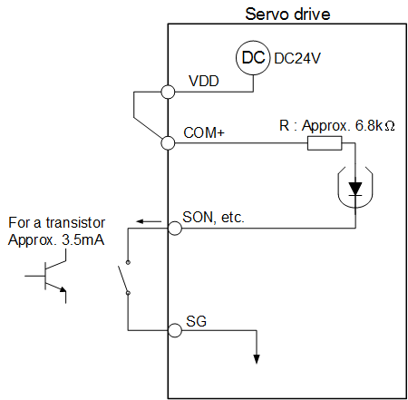 | 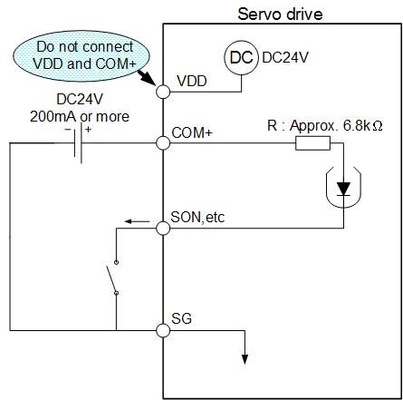
DI of source mode:
With the inner power supply | With the external power supply
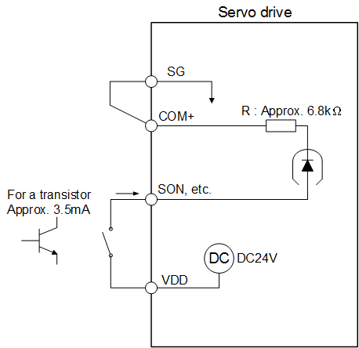 | 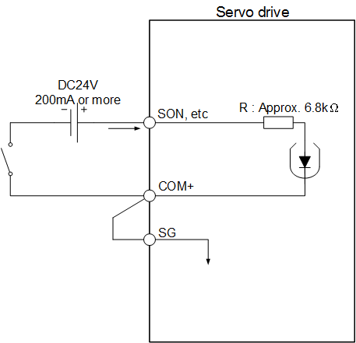

DO interface:
Lamp, relay or photo coupler could be driven. A diode for relay load, or a suppressing resistor for lamp load is necessary. (Permissible current: 40mA or less, inrush current: 100mA or less)

DO of sink mode
With the inner power supply | With the external power supply
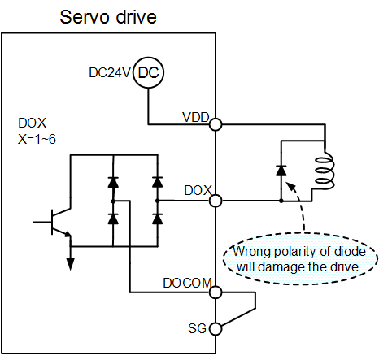 | 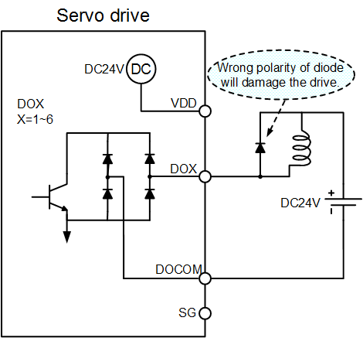
DO of source mode
With the inner power supply | With the external power supply
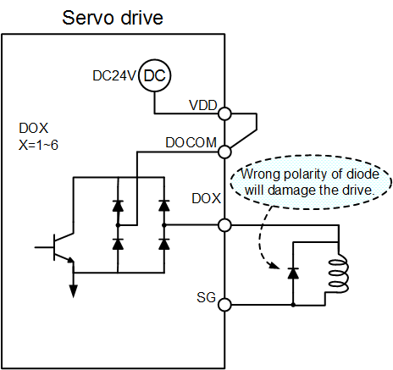 | 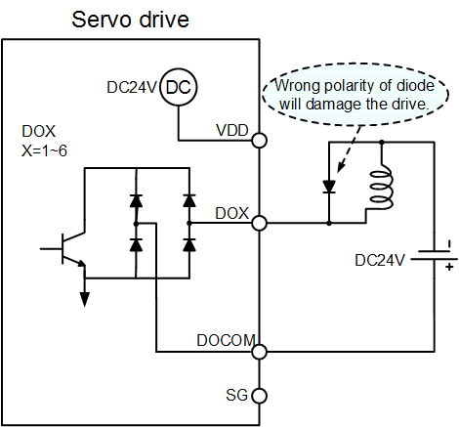

9.CN2 Encoder signal wiring and description
CN2 connector (female)
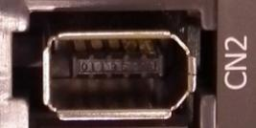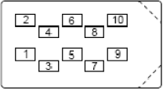
Capacity | Model | 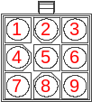
100W | SME－L01030○□□
200W | SME－L02030○□□
400W | SME－L04030○□□
750W | SME－L07530○□□
1KW | SME－□10020○□□ |  | 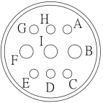
1.5KW | SME－□15020○□□
2KW | SME－□20020○□□
3KW | SME－□30020○□□

Drive Side |  |  | Motor Side Pin No.
Pin No. | Sign | Function description | Quick connector  (low Capacity) | Military Connector  (Middle Capacity)
1、3 | Vcc(5V) | +5V power supply for encoder | 7 | B
2、4 | GND | Battery power ground | 8 | F
2、4 | GND | Encoder power ground | 4 | A
5 | Vcc(3.6V) | battery supply 3.6V | 3 | H
6 | ENCP | Encoder communication (+) | 6 | D
7 | ENCN | Encoder communication (-) | 5 | E
- | Shielding | Shielding | 9 | I

Driver model | Encoder wiring (AWG)
Driver model | Line specification |  | Long line | Line Number | Line size
SDE－010A2□ | UL1332 | 2M |  | 10strip | AWG26
SDE－020A2□ | UL1332 | 2 M |  | 10 strip | AWG26
SDE－040A2□ | UL1332 | 2 M |  | 10 strip | AWG26
SDE－075A2□ | UL1332 | 2 M |  | 10 strip | AWG26
SDE－100A2□ | UL1332 | 2 M |  | 10 strip | AWG26
SDE－150A2□ | UL1332 | 2 M |  | 10 strip | AWG26
SDE－200A2□ | UL1332 | 2 M |  | 10 strip | AWG26
SDE－300A2□ | UL1332 | 2 M |  | 10 strip | AWG26

10. CN3 communication port signal wiring and description
CN3 port is for RS-485 communication，The RS485 format provides a longer distance communication and multiple drives application.
Note: Shihlin servo RJ45 feet a definition and standard RJ45 definition, must be noticed when wiring
Pin NO | Sign | Function description
6~8 | GND | signal power ground
1~3 | GND | signal power ground
5 | RS-485-A | Data are transmitted in differential line driver.  Line driver A.
4 | RS-485-B | Data are transmitted in differential line driver.  Line driver B.
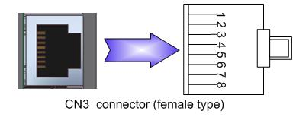

11. CN4 USB communication port
CN4 port is for USB communication. With the Shihlin servo communication software, users could connect it to the computer then set parameters, monitor the status, operate and test, etc.
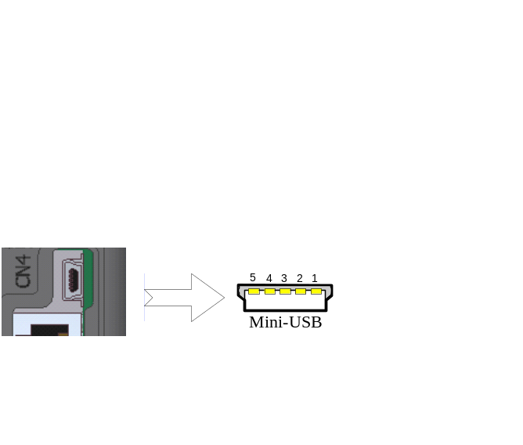
Pin NO | Function description
1 | +5V
2 | D-
3 | D+
4 | NC
5 | GND

12. CN5 battery power socket
When the absolute encoder servo motor is performed, the backup power for absolute encoder is necessary. The SDE servo drive provides a socket which the power wires of battery box could plug in.
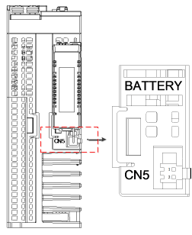

Pin NO | Sign | Function description
1 | Vcc(3.6V) | The battery power voltage is 3.6 volt.
2 | GND | The battery power ground.

13. Standard wiring method
Wiring diagram of position control(Pr Mode)
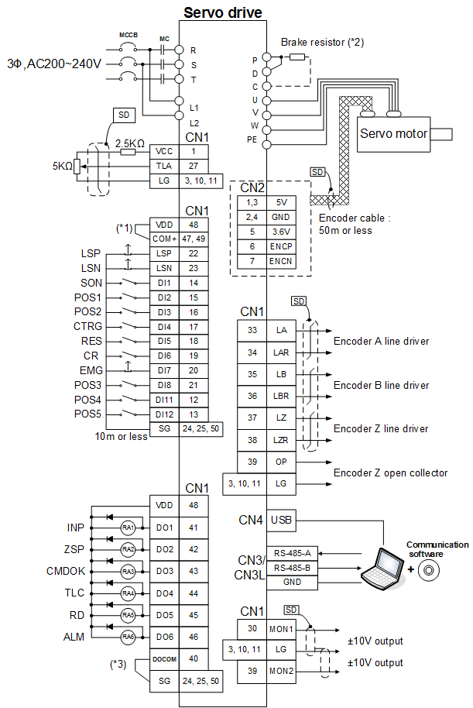
Note: 1.If the external power is applied, do not connect VDD and COM+.
2. See section 3.1 for the wirings of brake resistor
3. See section 3.3.6 for DO sink or source wiring.

Wiring diagram of position control(Pt Mode)

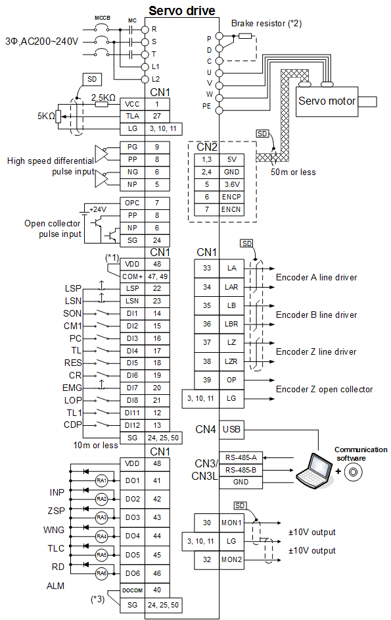
Note: 1.If the external power is applied, do not connect VDD and COM+.
2. See section 3.1 for the wirings of brake resistor
3. See section 3.3.6 for DO sink or source wiring.

Wiring diagram of speed control(S Mode)
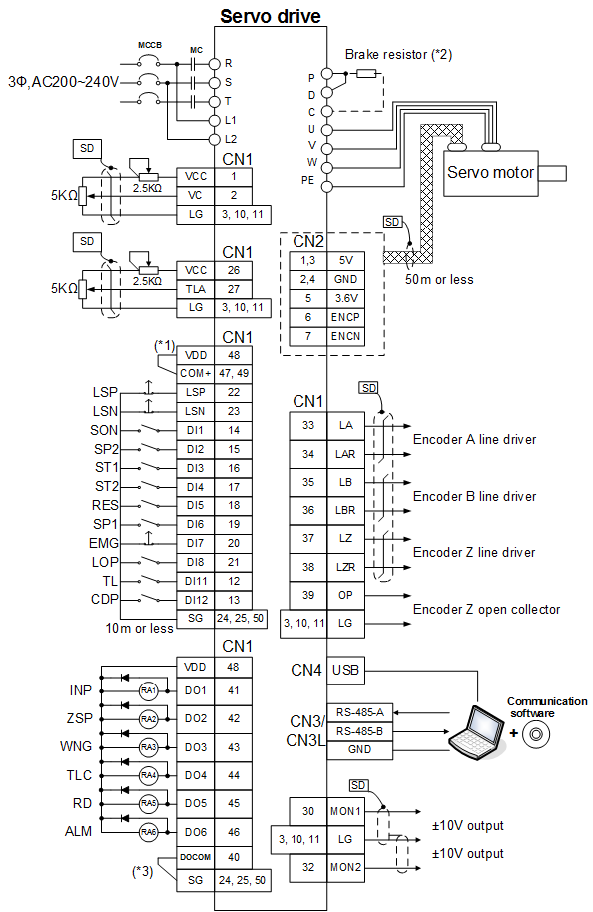
Note: 1.If the external power is applied, do not connect VDD and COM+.
2. See section 3.1 for the wirings of brake resistor
3. See section 3.3.6 for DO sink or source wiring.

Wiring diagram of speed control (T Mode)
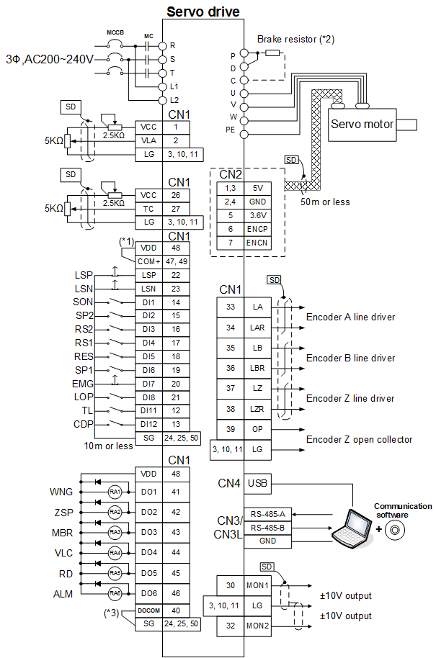
Note: 1.If the external power is applied, do not connect VDD and COM+.
2. See section 3.1 for the wirings of brake resistor.
3. See section 3.3.6 for DO sink or source wiring.

14. Appearance and Dimensions
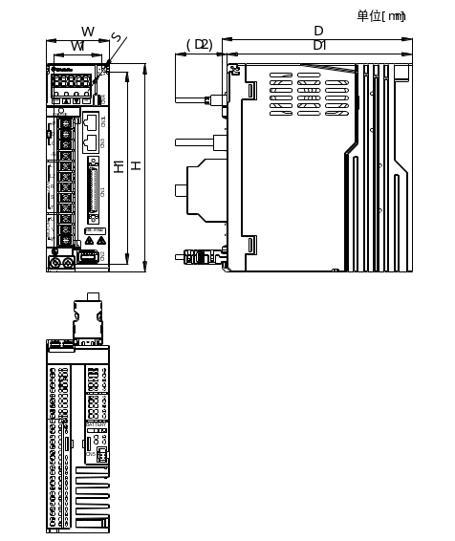 Unit:mm
Type | Frame | W | W1 | H | H1 | D | D1 | D2 | S
SDE-010A2(U) | A | 50 | 38 | 162 | 150 | 150 | 146 | 80 | 5.5
SDE-020A2(U) | A | 50 | 38 | 162 | 150 | 150 | 146 | 80 | 5.5
SDE-040A2(U) | A | 50 | 38 | 162 | 150 | 150 | 146 | 80 | 5.5
SDE-075A2(U) | B | 70 | 58 | 162 | 150 | 170 | 166 | 80 | 5.5
SDE-100A2(U) | B | 70 | 58 | 162 | 150 | 170 | 166 | 80 | 5.5
SDE-150A2(U) | C | 85 | 73 | 162 | 150 | 190 | 186 | 80 | 5.5
SDE-200A2(U) | C | 85 | 73 | 162 | 150 | 190 | 186 | 80 | 5.5
SDE-300A2(U) | C | 85 | 73 | 162 | 150 | 190 | 186 | 80 | 5.5

15. Motor dimensions
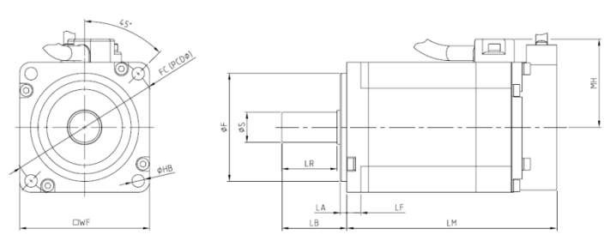

Unit：mm
Type | WF | S | F | LA | LB | LF | LR | MH | LM | FC | HB
SME-L005(B) | 40 | 8 | 30 | 2.5 | 25.5 | 5.5 | 21.5 | 31 | 64.5(99.2) | 46 | 2-ψ4.5
SME-L010(B) | 40 | 8 | 30 | 2.5 | 25.5 | 5.5 | 21.5 | 31 | 80.0(114.7) | 46 | 2-ψ4.5
SME-L020(B) | 60 | 14 | 50 | 3 | 30 | 6.5 | 25 | 41 | 77.0(112.0) | 70 | 4-ψ5.8
SME-L040(B) | 60 | 14 | 50 | 3 | 30 | 6.5 | 25 | 41 | 97.0(132.0) | 70 | 4-ψ5.8
SME-L075(B) | 80 | 19 | 70 | 3 | 40.7 | 7.5 | 35.5 | 51 | 102.0(141.0) | 90 | 4-ψ6.6
SME-L100(B) | 130 | 24 | 110 | 3 | 55 | 11 | 50 | 113 | 127.0(161.0) | 145 | 4-ψ9.0
SME- L150(B) | 130 | 24 | 110 | 3 | 55 | 11 | 50 | 113 | 141.5(175.5) | 145 | 4-ψ9.0
SME- L200(B) | 130 | 24 | 110 | 3 | 55 | 11 | 50 | 113 | 156.0(190.0) | 145 | 4-ψ9.0
SME- L300(B) | 130 | 24 | 110 | 3 | 55 | 11 | 50 | 113 | 185.0(219.0) | 145 | 4-ψ9.0
SME-M100(B) | 130 | 24 | 110 | 3 | 55 | 11 | 50 | 113 | 127.0(161) | 145 | 4-ψ9.0
SME-M150(B) | 130 | 24 | 110 | 3 | 55 | 11 | 50 | 113 | 141.5(175.5) | 145 | 4-ψ9.0
SME-M200(B) | 176 | 35 | 114.3 | 3 | 78 | 18.5 | 74 | 139 | 139.0(189) | 200 | 4-ψ13.5
SME-M300(B) | 176 | 35 | 114.3 | 3 | 78 | 18.5 | 74 | 139 | 169.0(219) | 200 | 4-ψ13.5
Note: ( ) inside value indicates the length of servo with electromagnetic brake.
D-cut shaft Key shaft
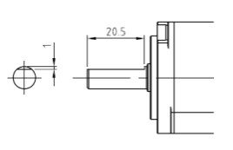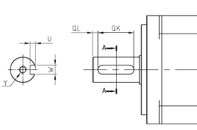
Type | QL | QK | W | U | Y
L020(B) \ L040(B) | 3 | 20 | 50 -0.03 | 3 | Screw: M4 Depth: 15
L075(B) | 5 | 25 | 60 -0.03 | 3.5 | Screw: M5 Depth: 20
L100(B) \ L150(B) \ L200(B)L300(B) \M100(B) \ M150(B) | 5 | 35 | 80 -0.036 | 4 | Screw: M8 Depth: 20
M200(B) \ M300(B) | 5 | 55 | 100 -0.036 | 5 | Screw: M8 Depth: 20
16. Option
Category | Name | model | Length(mm)
Encoder connector(CN2) | Low inertia(100W~750W) encoder connector | SDH-ENCNL | --
Encoder connector(CN2) | Low/Middle inertia（1KW~3KW）encoder connector | SDH-ENCNM | --
Encoder Cable | Low inertia(100W~750W) encoder cable 2M | SDH-ENL-2M-L/H | 2000±100
Encoder Cable | Low inertia(100W~750W) encoder cable 5M | SDH-ENL-5M-L/H | 5000±100
Encoder Cable | Low inertia(100W~750W) encoder cable 10M | SDH-ENL-10M-L/H | 10000±100
Encoder Cable | Low/Middle inertia（1KW~3KW）encoder cable 2M | SDH-ENM-2M-L/H | 2000±100
Encoder Cable | Low/Middle inertia（1KW~3KW）encoder cable 5M | SDH-ENM-5M-L/H | 5000±100
Encoder Cable | Low/Middle inertia（1KW~3KW）encoder cable 10M | SDH-ENM-10M-L/H | 10000±100
Power Connector | Low inertia((100W~750W) power connector without brake | SDA-PWCNL1 | --
Power Connector | Low inertia( (100W~750W) power connector with brake | SDA-PWCNL2 | --
Power Connector | Low（1KW~3KW/Middle inertia（1KW/1.5KW）power connector | SDA-PWCNM1 | --
Power Connector | Middle inertia（2KW/3KW）power connector | SDA-PWCNM2 | --
Power Cable | Low inertia((100W~750W) power cable 1 (without brake) | SDE-PWCNL1-2M-L/H | 2000±100
Power Cable | Low inertia((100W~750W) power cable 2 (without brake) | SDE-PWCNL1-5M-L/H | 5000±100
Power Cable | Low inertia((100W~750W) power cable 3 (without brake) | SDE-PWCNL1-10M-L/H | 10000±100
Power Cable | Low inertia((100W~750W) power cable 1 (with brake) | SDE-PWCNL2-2M-L/H | 2000±100
Power Cable | Low inertia((100W~750W) power cable 2 (with brake) | SDE-PWCNL2-5M-L/H | 5000±100
Power Cable | Low inertia((100W~750W) power cable 3 (with brake) | SDE-PWCNL2-10M-L/H | 10000±100
Power Cable | Low（1KW~3KW）/Middle inertia（1KW/1.5KW）  power cable 1 (without brake) | SDE-PWCNM1-2M-L/H | 2000±100
Power Cable | Low（1KW~3KW）/ Middle inertia（1KW/1.5KW）  power cable 2 (without brake) | SDE-PWCNM1-5M-L/H | 5000±100
Power Cable | Low（1KW~3KW）/ Middle inertia（1KW/1.5KW）  power cable 3 (without brake) | SDE-PWCNM1-10M-L/H | 10000±100
Power Cable | Low（1KW~3KW）/ Middle inertia（1KW/1.5KW）  power cable 1 (with brake) | SDE-PWCNM1B-2M-L/H | 2000±100
Power Cable | Low（1KW~3KW）/ Middle inertia（1KW/1.5KW）  power cable 2 (with brake) | SDE-PWCNM1B-5M-L/H | 5000±100
Power Cable | Low（1KW~3KW）/ Middle inertia（1KW/1.5KW）  power cable 3 (with brake) | SDE-PWCNM1B-10M-L/H | 10000±100
Power Cable | Middle inertia（2KW/3KW）power cable1 (without brake) | SDE-PWCNM2-2M-L/H | 2000±100
Power Cable | Middle inertia（2KW/3KW）power cable 2 (without brake) | SDE-PWCNM2-5M-L/H | 5000±100
Power Cable | Middle inertia（2KW/3KW）power cable 3 (without brake) | SDE-PWCNM2-10M-L/H | 10000±100
Power Cable | Middle inertia（2KW/3KW）power cable 1 (with brake) | SDE-PWCNM2B-2M-L/H | 2000±100
Power Cable | Middle inertia（2KW/3KW）power cable 2 (with brake) | SDE-PWCNM2B-5M-L/H | 5000±100
Power Cable | Middle inertia（2KW/3KW）power cable 3 (with brake) | SDE-PWCNM2B-10M-L/H | 10000±100
Communication Cable(CN4) | USB communication cable between drive and PC | SDA-USB3M | 3000
Communication Cable (CN3/CN3L) | USB Adapter | USB01
Communication Cable (CN3/CN3L) | Data transit cable 1.5m | SNKCBL1R5GTN2 | 1500
Communication Cable (CN3/CN3L) | Data transit cable 3m | SNKCBL3GTN2 | 3000
Communication Cable (CN3/CN3L) | Data transit cable 5m | SNKCBL5GTN2 | 5000
Communication Cable (CN3/CN3L) | Data transit cable 10m | SNKCBL10GTN2 | 10000
I/O Connector  (CN1) | I/O Connector | SDA-CN1 | --
I/O Connector  (CN1) | I/O connector terminal cable 0.5m | SDA-TBL05M | 500±10
I/O Connector  (CN1) | I/O connector terminal cable 1m | SDA-TBL1M | 1000±10
I/O Connector  (CN1) | I/O connector terminal cable 2m | SDA-TBL2M | 2000±10
I/O Connector  (CN1) | I/O connector terminal | SDA-TBL50 | --
Battery Set  (CN5) | Absolute encoder battery set | SDH-BAT-SET | --
Battery Set  (CN5) | Absolute encoder battery | SDH-BAT | --
17. Others
For excelsior products, the parameters and contents may be modified, please contact the agent or refer to Shihlin websites (http://automation.seec.com.tw/) to download the latest version.

18.Appendix 1
Shihlin Electric&Engineering Co., LTD V1.02 OCT, 2020

